2018
Hazard, Incident and Near Miss Reporting Procedure
Rottnest island authority
internal audit & risk management

1.0 Purpose
To provide the process for internal notification, reporting; and investigating environment, health and safety; and visitor, hazards, incidents and near misses across the Rottnest Island Authority agency.

2.0 Scope
This procedure covers the internal notification and reporting of all environment, occupational health and safety; and visitor; hazards, incidents and near misses located on Rottnest Island and at the Rottnest Island Authority E-Shed Office. For Emergency Response Management and Procedures see Emergency procedures .
Attention: If this is an emergency or fire call 000:
Police: 000 Fire: 000 Nursing Post: 000/ 9292 5030 Rangers: 9372 9788

3.0 Definitions
Hazard: A source or a situation with a potential for harm in terms of human injury or ill-health, damage to property, damage to the environment, or a combination of these.
Incident: Where an event occurred that did cause harm or injury to a person. Includes first aid, medical treatment and lost time injuries - e.g. Sprained ankle exiting truck.
Near-miss: Where an event occurred that did not cause harm or injury to a person - e.g. machinery damage with no injury to operator.
Risk: The likelihood and consequence of that injury or harm occurring.
Incident Types:
Visitor Risk: If the hazard, near-miss, or incident involved visitors to Rottnest Island’s managed land and waters or at E-Shed.
Environmental: If the hazard, near-miss or incident relates to the environment of Rottnest Island reserve.
Examples of environmental incidents include, but are not limited to:
- Unauthorised leak, spill or escape of petrochemical, toxic or hazardous substances;
- Sudden and uncontrolled emission or discharge of air pollutants (e.g. NOx – nitrogen oxides), or sudden and uncontrolled gaseous releases (e.g. H2, propane, compressed CO2, natural gas);
- Discharge of harmful substances into water Injury, illness or death of wildlife at greater than natural mortality rates; and
- Damage to wildlife or habitat.
Occupational Health and Safety (OHS): any hazard, near-miss or incident resulting in, or having a potential for injury, ill health, damage or other loss involving RIA, PFM and contractor staff.

Notifiable Incident (OHS) - includes the death of a person, a notifiable injury, notifiable illness/disease or a dangerous incident.
Notifiable Injury - a serious injury which includes:
- Death of a Worker
- A fracture of the skull, spine or pelvis
- A fracture of any bone:
- In the arm (other than in the wrists or hands)
- In the leg (other than the foot or ankle)
- An amputation of an arm, hand, finger, finger joint, leg, foot, toe or toe joint.
- The loss of eye sight
- Any Injury other than the above which in the opinion of the medical practitioner is likely to prevent the worker from being fit for work within 10 days of the day on which the injury occurred.
Notifiable diseases- diseases that include:
- Infectious diseases: tuberculosis, viral hepatitis, legionnaire's disease and HIV where these diseases are contracted during work involving exposure to human blood products, body secretions, excretions or other material which may be a source of infection.
- Occupational zoonoses: Q fever, anthrax, leptospiroses and brucellosis where these diseases are contracted during work involving the handling of, or contact with, animals, animal hides, skins, wool, hair, carcases or animal waste products.
Reportable Environmental Incident - an Environmental Incident is defined as reportable if it relates to:
A possible breach of Commonwealth, State and RIA environmental law involving RIA employees, contractors and visitors located on the Rottnest Island Reserve or RIA Fremantle Offices, where the incident is likely to:
- Cause environmental harm outside of existing environmental approval;
- Attract negative media or parliamentary attention;
- Adversely affect future RIA operations including the restriction of access related to the requirement for remediation of a particular site; and
- A breach of an internal and/or external environmental approval.
Incident Risk Impact Rating Level - refer to the RIA’s Risk Management Framework.
Rottnest Island Reserve - defined in the Rottnest Island Act 1987, the Rottnest Island Reserve is (a) the land containing 1859 hectares comprising Swan Location 10976 as shown and bordered pink, at the commencement of Rottnest Island Act 1987, on Department of Land Administration 2 Plan No. 16860; and (b) the waters comprising Swan Location 11022 as shown in the Rottnest Island Act 1987 on Department of Land Administration 2 Plan No. 16932, including the sea-bed and subsoil beneath such waters, being Reserve No. 16713 in the records of the Department of Land Administration 2.
E-Shed Office: Rottnest Island Authority’s offices located at E-Shed Victoria Quay, Fremantle WA 6160.

4.0 Roles and Responsibilities
HIN Coordinator: Develop, coordinate, communicate and review this procedure. Maintains a register of all reports received and reportable/ notifiable incidents (located on HPE Content Manager). Report applicable incidents to appropriate external regulators.
External Regulators – such as Worksafe for all notifiable injuries and dangerous occurrences with WA for OSH.
All RIA staff, contractors and lessees: Responsible for reporting all suspected, potential, and actual environmental, OHS, and Visitor hazards, near-misses and incidents.
RIA Rangers: Management of emergency and wildlife response across the reserve.
Health and Safety Representative(s): Coordinate and manage the health and safety issues associated with the report received. Assist in the investigation of OSH incidents, near-misses and hazard where appropriate and/or identify corrective actions.
Environmental staff members: Coordinate and manage the environment issues associated with the report received. Investigate and/or identify corrective actions for environmental incidents, near-misses and hazards where appropriate.
PFM Operations Manager: Responsible for reporting all suspected, potential, and actual environmental, OHS, and Visitor hazards, near-misses and incidents from PFM.
Responsible Party: is the person responsible for ensuring action is taken in response to a HIN Report. This may include assigning / directing HIN Reports to the right RIA or PFM personnel for actioning i.e. logging a job with PFM for tree pruning. The following persons are typically the Responsible Party:
- OHS (RIA E-Shed only) – RIA Health and Safety Representative/Safety Officer (where applicable);
- Health and Safety (Island) – Jodie Mott, Operations Manager Programmed (cc: Manager, Major Contracts and Project and Contract Admin Officer);
- Visitor Risk – Jodie Mott and/or RIA member trained in Visitor Risk Management (Manager, Parks); and
- Environment – Manager, Environment, Sustainability and Compliance.
Person to Action: Person assigned to address and implement corrective actions for the hazard, incident or near miss. In some case’s this may be the same person as the Responsible Party.

5.0 Incident Response
Refer to Appendix 1 – Flow Chart for Emergency and Hazard, Incident Notification and Reporting; Appendix 3 – Flow Chart of Responsible Personnel; and the Roles and Responsibilities (section 4 of this document).
For Emergency Response Procedures see Local Emergency Management Arrangements.
Attention: The form is to be filled out as soon as practicable. Do not fill out the form if you are still responding to the incident. Ensure the proper notification has occurred when safe to do so in accordance to Appendix 1.

6.0 Form Use
All RIA and PFM employees, as well as contractors must complete this form whenever an Environment, Health and Safety, or Visitor Hazard, Near Miss, or Incident is observed or occurs. This applies to all occurrences applicable to the definitions of:
- Environmental Hazard, Incident or Near-miss
- Visitor Hazard, Incident or Near-miss
- Occupational Health and Safety (OHS) Hazard, Incident or Near-miss
Where an incident or hazard is reported on an external organisation form for purposes of jurisdiction, the notifier can stop after completing Reporting details and attach a copy of the external report. This is not for reportable incidents but for incidents that are investigated by Department of Fisheries, Department of Biodiversity, Conservation and Attractions, WA Police, etc. on behalf or in lieu of Rottnest Island.

7.0 Form Procedure
7.1 Type of Incident
Tick the applicable box for type of incident.
If more than one occurred tick all boxes that apply. For example, a visitor falls from their bicycle (sustaining graze to right knee) due to a collision with a quokka in the settlement area; therefore, you would tick both; Visitor incident (due to injury to visitor) and Environment (due to quokka harm).
7.2 Type of Report
This indicates whether the notifier is reporting a Hazard, Near Miss, or Incident. One must be chosen for each ‘type of incident’ checked.
7.3 Immediate Hazard
Choose the hazard that has caused or has potential to cause the impact or outcome. For example, if a vehicle hits someone or wildlife, the vehicle is the hazard.
7.4 Impact/Outcome
Choose the actual or potential impact caused by the immediate hazard. For impacts of visitor incidents, please include a description of the impact in the Description section of the form.
7.5 Reporting Details.
Complete as many details as possible. See definition of notifier above. Enter N/A where not applicable.
Note: Where an incident or hazard is reported on an external organisation form for purposes of jurisdiction, the notifier can stop after completing “Reporting details” and attach a copy of the external report (see 6.0 Form Use).
7.6 Incident Details
Complete as many details as possible. Include date and time of the incident. Choose the general area from the drop down, and then specify the location name, unit name/number etc. in the text box. GIS Coordinates can be taken with a phone or other gps device. Choose who was involved, tick as many as applies. Where it does not involve a person, i.e. wildlife, check the person involved in the response. I.e. Ranger.
7.7 Injury Details
Injury Details is only to be completed if an Occupational, Safety or Health or Visitor injury occurs. If it is injury to wildlife, or any other type of incident, skip this section and go to ‘Full Description of Incident’ (7.8) to describe the injury/damage. Where an injury has occurred, check all boxes applicable starting with injury name, then location and lastly if treatment was administered.

7.8 Full Description of Incident
This is a narrative description of the incident and should include: Who, What, Where and When; and if immediately known without investigation How and Why. Include as many details as possible.
7.9 Attachments
List file names and descriptions of files you are sending with the form as evidence, i.e. diagrams, photographs, and maps. You can also refer to a HPE Content Manager document number if applicable, instead of emailing the file.
7.10 Immediate Remedial Actions Undertaken
What immediate actions, if any, were taken to eliminate, reduce the hazard or respond to the impact. If first-aid was administered include details in this section. Where treatment or euthanasia for an animal is required input details here.
7.11 Acknowledgement
Input the reporting person’s details, this is the person who completed the report. The notifier is not always the reporting person. For example, if a guest wants to report an incident the notifier may be the guest, but the reporting person will be whoever completed the form for that person, i.e. visitor centre employee. Another example could be a contractor reporting to an RIA employee.
Attention: If the reporting person is not an RIA employee and you have finished filling out this form, please email the form to HIN@rottnestisland.com.

THE BELOW FIELDS ARE FOR COMPLETION BY HIN COORDINATOR ONLY
7.11 Risk Rating
Refer to the Risk Analysis Reference table within the RIA’s Risk Management Framework on the intranet, to identify the level of risk dependant on the severity of the impact/ hazard. The drop-down list will then provide you with the below choices; insignificant, minor, moderate, major; and extreme.
7.12 Investigation Team
Identify the names of the relevant OSH/ Environmental staff involved in the investigation, along with the relevant RIA managers/ supervisors or external person that will coordinate the investigation process.
If this is a reportable/ notifiable incident (either OSH or Environment) advise the external body reported to and any other relevant information.
7.13 Stakeholders That Need to be Informed
This section is utilised to ensure that all relevant stakeholders are informed of the incident that occurred (impacts on their area of control, a procedure within their area requires review, or it relates to a staff member within that Business Unit), the Stakeholder needs to take any necessary actions following notification, and also provide feedback and cooperation during the investigation process.
- Park Services – related to Park Services staff members or processes;
- Fire and Emergency Services – related to Fire and Emergency Services processes;
- Nursing Post – related to processes involving Emergency Response/ Medical Treatment;
- PFM – Involved PFM staff members, requires review of PFM processes or informing PFM of any updates to RIA procedures that are relevant to PFM;
- Infrastructure and Contracts – Related to project management processes or contracts managed;
- Marketing & Events – Related to marketing products or processes and/or events undertaken at Rottnest Island and processes within Events control;
- Internal Audit & Risk Management – Related to policy and procedural reviews across RIA; and
- Other – Any other Business Unit or External party that needs to be notified of incident report.
7.14 Corrective Actions
Once the investigation of the incident is complete, a number of corrective actions are decided upon between the investigation team to ensure that a similar incident does not occur again and to aim for continual improvement of RIA processes and procedures. Each corrective action is assigned to a responsible person to implement and ensure completion. The completion date is input once the corrective action is in place and proof has been provided to a member of the investigation team.
7.15 Completion of Report
This section is the final item to be completed on this form, once the investigation is complete this is to be closed out by either a member of the Responsible Persons Internal Audit and Risk Management team, closing comments can be provided with regards to progress and/ or completion of corrective actions.

8.0 Filing Incident Reporting Forms
It is the responsibility of the Information Services Officer and HIN Coordinator to ensure that all reports received by IARM are filed within the HPE Content Manager system, into the appropriate folder.
HIN Reports are received via the HIN inbox and filed by Information Services in the first instance before being forwarded to the Risk Coordinator for recording in the HIN Register and assigning to the relevant person(s).
8.1 HPE Content Manager folders relevant to hazard, incident and near miss reporting:
- 18/2 – Health and Safety – RISK MANAGEMENT – Critical Incident Reports/ Hazard, Incident and Near Miss Forms – 20XX
8.2 Format for recording within TRIM
INITIAL HIN - [report type] –Person – place or thing – date – description – location details – report Examples:
- INITIAL HIN - Incident – Mary David – 3 July 2015 – Fall from bike – Henrietta Rocks – report
- INITIAL HIN - Incident – quokka – 20 July 2015 – Quokka death by vehicle – PFM yard – report

Appendix 1 – Flow Chart for Incident Notification and Reporting
INCIDENT CLOSED by HIN Coordinator
CONTACT EMERGENCY SERVICES IF HUMAN HEALTH IS AT RISK OR IN CASE OF FIRE
Police: 000 Fire: 000 Nursing Post: 9292 5030 / 000

Near Miss or Hazard
Notify appropriate Manager as soon as possible (no more than 12 hours after the incident) and CC: Executive Director

Assess the type of Incident (defined above)
Environment or Health & Safety Staff to report incident to external regulators (if required) and notify Environment, Heritage and Parks Director and Manager People Services Branch
Undertake action to isolate & control the incident as directed by the Environmental Services Manager / Health & Safety Officer or Executive Director
Complete HIN Report Form as per above instructions.
- Supply as much information as possible.
- Collect and include Evidence were practicable (i.e. photographs, GPS data, diagrams etc.)
- E-mail the report and evidence to: HIN@rottnestisland.com

Reportable/Notifiable Incidents
OSH, Visitor Risk or Environment Incident
HIN Coordinator to log in HIN Register and assign HIN Report to Responsible Party (Appendix 3) to identify and implement corrective actions or undertake investigation if it is a reportable notifiable incident.
HIN Coordinator to update HIN register.

Provide evidence of action completion to HIN Coordinator Coordinator
Assign and complete any required Actions to eliminate the hazard and or mediate the impact
Monthly Incident Report to Board

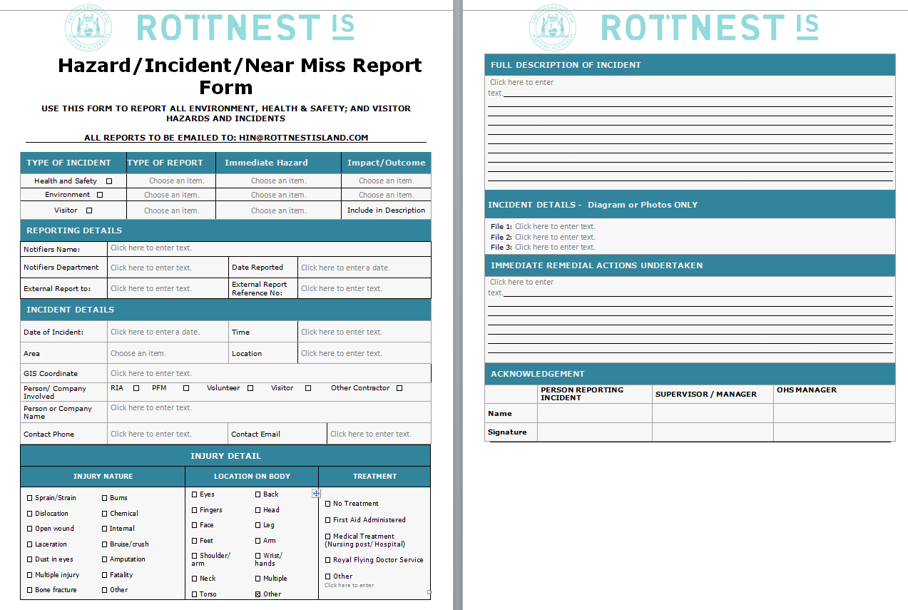
Appendix 2 – Hazard, Incident, Near Miss Reporting form

Appendix 3 – Hazard, Incident, Near Miss Flow Chart Responsible Personnel
Terrestrial Reserve
Accommodation Units
Environmental Incidents
E-Shed Office
Jetties
Manager, Parks

Responsible Manager
Contractor Issues

OSH RIA Staff
Director, Projects and Contracts
PFM
Office Manager
Director, Infrastructure
Manager, Transport Infrastructure

Roads/Rail
Manager, Environment, Sustainability and Compliance Services
Manager, Park Services
Director, Visitor Services

